**Project Design Phase-II**

**Data Flow Diagram & User Stories**

|  |  |
| --- | --- |
| Date | 03 October 2022 |
| Team ID | PNT2022TMID31434 |
| Project Name | Project - Smart farmer-IOT enabled smart Farming Application |
| Maximum Marks | 4 Marks |

**Data Flow Diagrams:**

A Data Flow Diagram (DFD) is a traditional visual representation of the information flows within a system. A neat and clear DFD can depict the right amount of the system requirement graphically. It shows how data enters and leaves the system, what changes the information, and where data is stored.

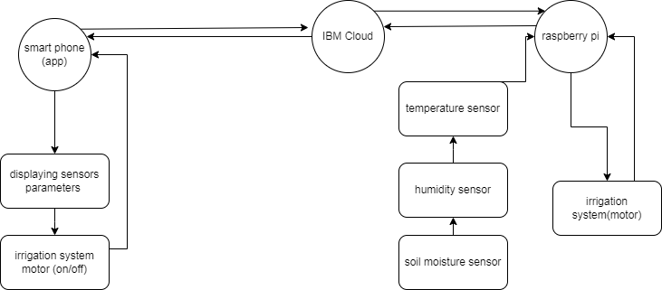

**User Stories**

Use the below template to list all the user stories for the product.

|  |  |  |  |  |  |  |
| --- | --- | --- | --- | --- | --- | --- |
| **User Type** | **Functional**  **Requirement (Epic)** | **User Story Number** | **User Story / Task** | **Acceptance criteria** | **Priority** | **Release** |
| farmer (Mobile app) | displaying sensor parameters | USN-1 | farmer can view temperature, humidity and soil moisture in his mobile connected to ibm cloud | displaying sensor parameters | High | Sprint-1 |
| farmer (Mobile app) | controlling irrigation | USN-2 | after seeing the sensor parameters farmer can turn on or off the irrigation system(motor) using mobile phone | controlling irrigation system | High | Sprint-1 |
| raspberry pi | microcomputer setup in farm field | USN-3 | temperature sensor, humidity sensor, soil moisture sensor and irrigation system is interface with raspberry pi which is connected to IBM cloud | smart farming system is setup in farm field | high | Sprint-2 |
| IBM cloud | Iot(data transfer) | USN-4 | raspberry pi is connected to IBM cloud to monitor and control farm field remotely using internet | data exchange using internet | Medium | Sprint-1 |